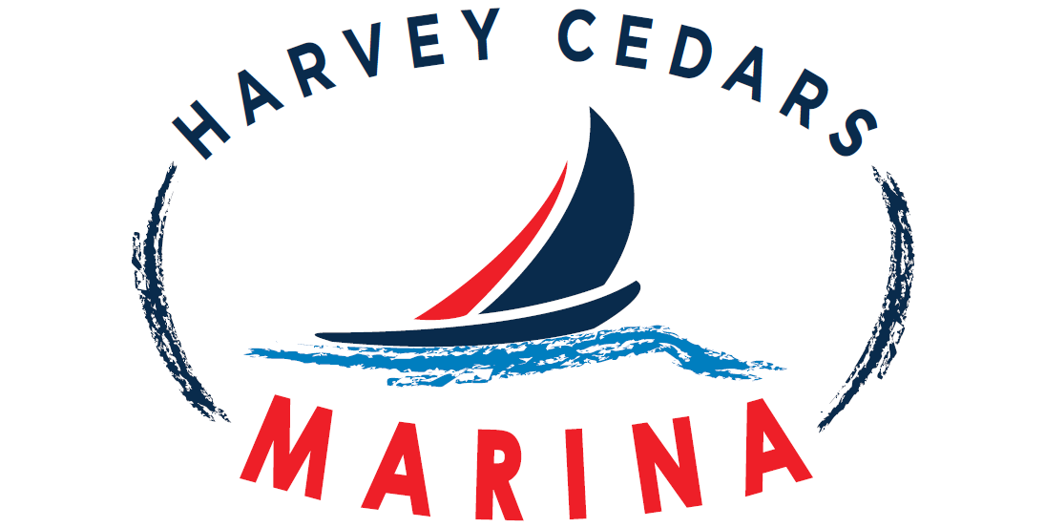
6318 Long Beach Boulevard, Harvey Cedars, NJ 08008

RENTAL AGREEMENT - WAIVER AND RELEASE FORM

Date& Time Out______________________________________ Return Date & Time ________________________

Equipment Rented: __Tandem kayak __Single Kayak __Wave __Sunfish ___Paddleboard ___Surfboard

⁭Seat(s) _______ ⁭Paddle(s) _______ ⁭ PFD(s) _______ ⁭ Mirage Drive(s) _______ ⁭Other _______________‬‬‬‬‬‬‬‬‬‬‬‬‬‬‬‬‬‬‬‬‬‬‬‬‬‬‬‬‬‬‬‬‬‬‬‬‬‬‬‬

Address: ______________________________________________________________________________________________
Emergency contact number__________________________________________________

I enter into this agreement for the purpose of renting a kayak(s) /sailboat(s) or paddleboard(s) from Harvey Cedars Marine, LLC.

I understand and acknowledge that the ocean and inland waterways are unpredictable and potentially hazardous which could result in injury to myself or damages to the rental equipment. I understand and acknowledge that I am responsible for any and all damage or loss to any equipment rented, whether caused by me, the weather, the elements, or third parties. I understand and acknowledge that failure to return the rental equipment in the same condition it was rented or failure to return the rental equipment at the time and date specified will result in additional charges or loss of all or part of my security deposit. Moreover, I hereby authorize Harvey Cedars Marine, LLC to make said charges against the credit card presented by me in connection with this rental or used for purposes of security deposit.

I understand and acknowledge that I am physically able to participate in this activity, and I will wear a personal floatation device (PFD) while participating in this activity. I knowingly and willing agree to assume all risks associated with the use of the rental equipment including all serious bodily injury death. I agree to waive and release, on behalf of myself, my heirs, executors, successors and servants, Harvey Cedars Marine, L.L.C., its employees, agents, and representatives from any liabilities of any kind and all claims arising out of my control and use of the rental equipment. I further agree that I, my heirs, executors, and successors will NOT SUE any of the persons or entities mentioned herein, and agree to indemnify and hold harmless Harvey Cedars Marine, LLC, its employees, agents and servants from any and all claims arising out of the use of the rental equipment.

I hereby affirm that I am at least 18 years of age or older. I acknowledge that I have read this document and by signing this agreement, I agree to be legally bound by the terms continued in this document.

__________________________ ________________________ ______________
(print name) (Signature) (Date)

__________________________ ________________________ ______________
(print name) (Signature) (Date)

MINORS:
For persons under eighteen (18) years of age, a parent or legal guardian must complete the following sections: The undersigned is the parent or legal guardian of written below. As the natural or legal guardian of such minor, I hereby bind myself, the minor, and the executor, administrators, heirs, next of kin, successors and assigns to the terms of the foregoing Waiver and Release Agreement and I represent that I have the legal capacity and authority to act for and on behalf of the minor named herein, and I agree to indemnify of any insufficiency of my legal capacity or authority to act for and on behalf of the minor in the execution of this consent.
1. ___________________ ______________________________ ___________________ _____________
(Minor’s name) (Print Name, Parent or guardian) (Signature) (Date)

2. ___________________ ______________________________ ___________________ _____________
(Minor’s name) (Print Name, Parent or guardian) (Signature) (Date)

3. ___________________ ______________________________ ___________________ _____________
(Minor’s name) (Print Name, Parent or guardian) (Signature) (Date)

4. ___________________ ______________________________ ___________________ _____________
(Minor’s name) (Print Name, Parent or guardian) (Signature) (Date)

5. ___________________ ______________________________ ___________________ _____________
(Minor’s name) (Print Name, Parent or guardian) (Signature) (Date)

